PIZZA SALES SQL QUERIES

1. KPI’S

1.Total Revenue

SELECT SUM(total_price) AS Total_Revenue from pizza_sales

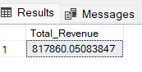

2.Average order value

SELECT SUM(total_price) / COUNT(DISTINCT order_id) as Avg_Order_Value from pizza_sales

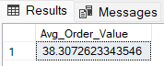

3. Total Pizza sold

SELECT SUM(quantity) AS Total_Pizza_Sold from pizza_sales

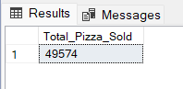

4.Total Order

SELECT COUNT(DISTINCT order_id) AS Total_Order from pizza_sales

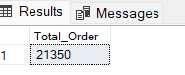

5. Average pizza per order

SELECT CAST(SUM(quantity) AS DECIMAL(10,2)) / CAST(COUNT(DISTINCT order_id)AS DECIMAL(10,2))AS Average_Pizza_Per_Order from pizza_sales

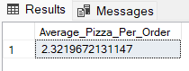

1. Chart Requirement
2. Daily Trend for total order

SELECT DATENAME(DW,order_date) as order_day,COUNT(DISTINCT order_id) AS Total_orders from pizza_sales

GROUP BY DATENAME(DW,order_date)

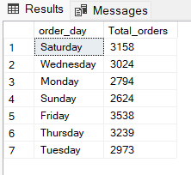

1. Monthly Trend for Total Order

SELECT DATENAME(MONTH,order_date) as Month_Name,

COUNT(DISTINCT order_id) AS Total_orders from pizza_sales

GROUP BY DATENAME(MONTH,order_date)

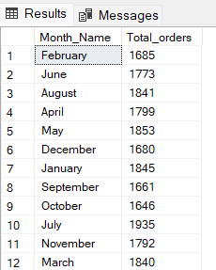

1. Hourly Trend order

SELECT DATEPART(HOUR, order_time) AS order_hours,COUNT(DISTINCT order_id)

AS total_orders

FROM pizza_sales

GROUP BY DATEPART(HOUR, order_time)

ORDER BY DATEPART(HOUR, order_time)

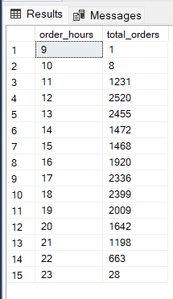

1. Percentage of sales of pizza category

SELECT pizza_category,sum(total_price) *100/

(SELECT SUM(total_price) from pizza_sales) from pizza_sales

GROUP BY pizza_category

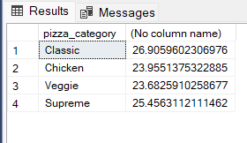

1. Percentage of sales of pizza category particular month

SELECT pizza_category,sum(sstotal_price) as Total_Sales, sum(total_price) *100/

(SELECT SUM(total_price) from pizza_sales where month (order_date)=1) as PCT

from pizza_sales

where month (order_date)=1

GROUP BY pizza_category

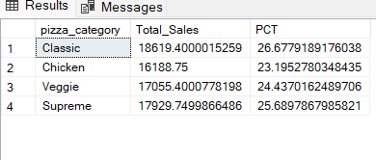

1. % SALES BY PIZZA CATEGORY

SELECT pizza_category,CAST(sum(total_price) AS DECIMAL(10,2)) as Total_Revenue,CAST( sum(total_price) *100/

(SELECT SUM(total_price) from pizza_sales) AS DECIMAL(10,2)) as PCT

from pizza_sales

GROUP BY pizza_category

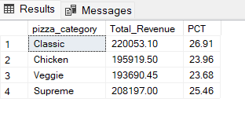

7.Total Pizzas sold by pizza category

SELECT pizza_size,sum(total_price) as Total_Sales, sum(total_price)*100/

(SELECT SUM(total_price) from pizza_sales) as PCT

from pizza_sales

GROUP BY pizza_size

ORDER BY PCT DESC

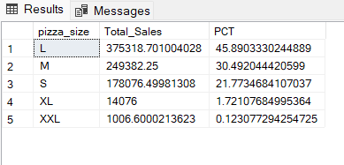

8. % SALES BY PIZZA SIZE

SELECT pizza_size,CAST(sum(total_price) AS DECIMAL(10,2)) as Total_Sales, CAST(sum(total_price) *100/

(SELECT SUM(total_price) from pizza_sales) AS DECIMAL(10,2)) as PCT

from pizza_sales

GROUP BY pizza_size

ORDER BY PCT DESC

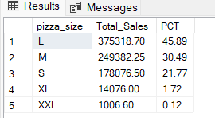

9 .Top 5 pizza Revenue

SELECT TOP 5 pizza_name, SUM(total_price) AS Total_Revenue FROM pizza_sales

GROUP BY pizza_name

ORDER BY Total_Revenue DESC

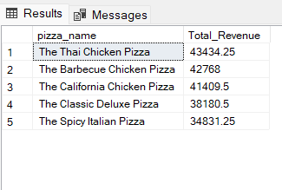

10.Botto 5 pizza revenue

SELECT TOP 5 pizza_name, SUM(total_price) AS Total_Revenue FROM pizza_sales

GROUP BY pizza_name

ORDER BY Total_Revenue ASC

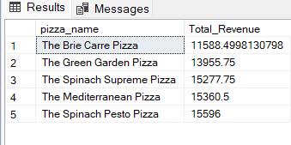

11. BOTTOM 5 SELLER BY TOTAL QUANTITY

SELECT TOP 5 pizza_name, SUM(quantity) AS Total_Quantity FROM pizza_sales

GROUP BY pizza_name

ORDER BY Total_Quantity ASC

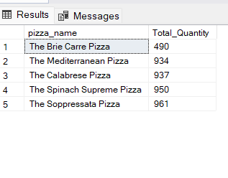

11. TOP 5 SELLER BY TOTAL QUANTITY

SELECT TOP 5 pizza_name, SUM(quantity) AS Total_Quantity FROM pizza_sales

GROUP BY pizza_name

ORDER BY Total_Quantity DESC

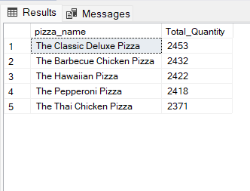

12. BOTTOM 5 SELLER BY TOTAL ORDER

SELECT TOP 5 pizza_name, COUNT(DISTINCT order_id) AS Total_Order FROM pizza_sales

GROUP BY pizza_name

ORDER BY Total_Order ASC

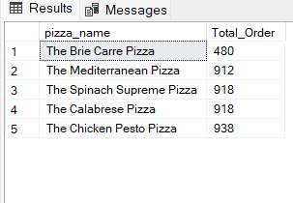

13. TOP 5 SELLER BY TOTAL ORDER

SELECT TOP 5 pizza_name, COUNT(DISTINCT order_id) AS Total_Order FROM pizza_sales

GROUP BY pizza_name

ORDER BY Total_Order DESC

